**Category**

* [Regression Models](https://datascienceplus.com/category/regression-models/)

**Tags**

* [ggplot2](https://datascienceplus.com/tag/ggplot2/)
* [Linear Regression](https://datascienceplus.com/tag/linear-regression/)
* [NHANES](https://datascienceplus.com/tag/nhanes/)
* [R Programming](https://datascienceplus.com/tag/rstats/)

In this post I will show how to build a linear regression model. As an example, for this post, I will evaluate the association between vitamin D and calcium in the blood, given that the variable of interest (i.e., calcium levels) is continuous and the linear regression analysis must be used. I will also construct multivariable-adjusted models to account for confounders.

Let's start loading the packages:

library(tidyverse)

library(RNHANES)

library(ggplot2)

Variables selected for this analysis include age, sex, plasma levels of vitamin D, and plasma levels of calcium. All variables are assessed from [NHANES](https://wwwn.cdc.gov/nchs/nhanes/Default.aspx) 2007 to 2010 wave.

d07 = nhanes_load_data("DEMO_E", "2007-2008") %>%

select(SEQN, cycle, RIAGENDR, RIDAGEYR) %>%

transmute(SEQN=SEQN, wave=cycle, RIAGENDR, RIDAGEYR) %>%

left_join(nhanes_load_data("VID_E", "2007-2008"), by="SEQN") %>%

select(SEQN, wave, RIAGENDR, RIDAGEYR, LBXVIDMS) %>%

transmute(SEQN, wave, RIAGENDR, RIDAGEYR, vitD=LBXVIDMS) %>%

left_join(nhanes_load_data("BIOPRO_E", "2007-2008"), by="SEQN") %>%

select(SEQN, wave, RIAGENDR, RIDAGEYR, vitD, LBXSCA) %>%

transmute(SEQN, wave, RIAGENDR, RIDAGEYR, vitD, Calcium = LBXSCA)

d09 = nhanes_load_data("DEMO_F", "2009-2010") %>%

select(SEQN, cycle, RIAGENDR, RIDAGEYR) %>%

transmute(SEQN=SEQN, wave=cycle, RIAGENDR, RIDAGEYR) %>%

left_join(nhanes_load_data("VID_F", "2009-2010"), by="SEQN") %>%

select(SEQN, wave, RIAGENDR, RIDAGEYR, LBXVIDMS) %>%

transmute(SEQN, wave, RIAGENDR, RIDAGEYR, vitD=LBXVIDMS) %>%

left_join(nhanes_load_data("BIOPRO_F", "2009-2010"), by="SEQN") %>%

select(SEQN, wave, RIAGENDR, RIDAGEYR, vitD, LBXSCA) %>%

transmute(SEQN, wave, RIAGENDR, RIDAGEYR, vitD, Calcium = LBXSCA)

dat = rbind(d07, d09)

all = dat %>%

# exclude missings

filter(!is.na(vitD), !is.na(Calcium)) %>%

mutate(Gender = recode_factor(RIAGENDR,

`1` = "Males",

`2` = "Females"))

head(all)

*## SEQN wave RIAGENDR RIDAGEYR vitD Calcium Gender*

*## 1 41475 2007-2008 2 62 58.8 9.5 Females*

*## 2 41477 2007-2008 1 71 81.8 10.0 Males*

*## 3 41479 2007-2008 1 52 78.4 9.0 Males*

*## 4 41482 2007-2008 1 64 61.9 9.1 Males*

*## 5 41483 2007-2008 1 66 53.3 8.9 Males*

*## 6 41485 2007-2008 2 30 39.1 9.3 Females*

The dataset is complete. Before running the regression analysis, the linear model, I will check the assumption, that the distribution of the dependent variable (levels of calcium) is normal.

Distribution of calcium level:

ggplot(data = all) +

geom_histogram(aes(Calcium), binwidth = 0.2)

[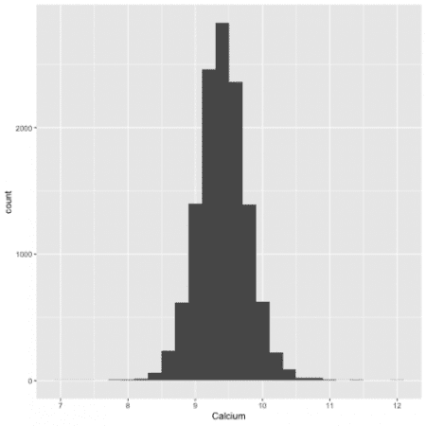](https://i0.wp.com/datascienceplus.com/wp-content/uploads/2019/05/unnamed-chunk-23-1.png?ssl=1)

It is a normal distribution.

Note: If the distribution is not normal, the dependant variable should be log transform by using log(Calcium).

**The model**

I will use the function lm() to create a linear regression model. In the first model I will not adjust for confunders, insted, I will do a univariate model.

fit1 <- lm(Calcium ~ vitD, data = all)

To see the results, estimates, pvalues etc use summary function.

summary(fit1)

*##*

*## Call:*

*## lm(formula = Calcium ~ vitD, data = all)*

*##*

*## Residuals:*

*## Min 1Q Median 3Q Max*

*## -2.51254 -0.23398 -0.00581 0.22943 2.64876*

*##*

*## Coefficients:*

*## Estimate Std. Error t value Pr(>|t|)*

*## (Intercept) 9.3517792 0.0087769 1065.50 <2e-16 \*\*\**

*## vitD 0.0016522 0.0001315 12.56 <2e-16 \*\*\**

*## ---*

*## Signif. codes: 0 '***' 0.001 '**' 0.01 '*' 0.05 '.' 0.1 ' ' 1*

*##*

*## Residual standard error: 0.3683 on 12389 degrees of freedom*

*## Multiple R-squared: 0.01258, Adjusted R-squared: 0.0125*

*## F-statistic: 157.8 on 1 and 12389 DF, p-value: < 2.2e-16*

The 95% confidence interval:

confint(fit1)

*## 2.5 % 97.5 %*

*## (Intercept) 9.334575125 9.368983370*

*## vitD 0.001394404 0.001910026*

**Intepretation**

From the results, I find that vitamin D is associated with calcium in the blood because the p-value is less than 0.05. Next, I see the direction of the association. The positive beta estimate (\(\beta\) = 0.0016) indicate that with increasing vitamin D in the blood, the levels of calcium also increases.

To visualize this association I will use the ggplot and the function geom_smooth. See below:

ggplot(all, aes(x = vitD, y = Calcium)) +

geom_point() +

geom_smooth(method="lm")

[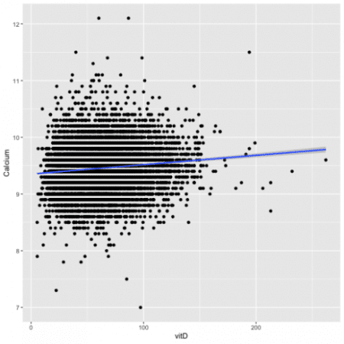](https://i1.wp.com/datascienceplus.com/wp-content/uploads/2019/05/unnamed-chunk-27-1.png?ssl=1)

The plot shows an increase of the levels of Calcium with the increase of vitamin D in the blood.

**Multivariable adjusted models**

Often, a significant association could be explained by confounders. According to [Wikipedia](https://datascienceplus.com/linear-regression-with-healthcare-data-for-beginners-in-r/Wikipedia), a confounder is a variable that influences both the dependent variable and independent variable, causing a spurious association. Therefore, it is important to adjust for major confounders such as age and gender. The levels of vitamin D in the blood are dependent to age because older adults have lower vitamin D in blood compared to young adults.

To conduct a multivariable-adjusted model I add other variables to the model, in this example, I will add age and gender.

fit2 <- lm(Calcium ~ vitD + Gender + RIDAGEYR, data = all)

summary(fit2)

*##*

*## Call:*

*## lm(formula = Calcium ~ vitD + Gender + RIDAGEYR, data = all)*

*##*

*## Residuals:*

*## Min 1Q Median 3Q Max*

*## -2.50114 -0.22824 -0.00857 0.22354 2.69352*

*##*

*## Coefficients:*

*## Estimate Std. Error t value Pr(>|t|)*

*## (Intercept) 9.4686333 0.0109933 861.307 <2e-16 \*\*\**

*## vitD 0.0019034 0.0001310 14.526 <2e-16 \*\*\**

*## GenderFemales -0.0653111 0.0065383 -9.989 <2e-16 \*\*\**

*## RIDAGEYR -0.0022455 0.0001581 -14.204 <2e-16 \*\*\**

*## ---*

*## Signif. codes: 0 '***' 0.001 '**' 0.01 '*' 0.05 '.' 0.1 ' ' 1*

*##*

*## Residual standard error: 0.3639 on 12387 degrees of freedom*

*## Multiple R-squared: 0.03619, Adjusted R-squared: 0.03596*

*## F-statistic: 155.1 on 3 and 12387 DF, p-value: < 2.2e-16*

The association between vitamin D and calcium remained significant after adjustment, suggesting that the association is independent (e.g., not explained) by age and gender.

**Stratifing analysis**

To evaluate the association separately in men and women is necessary to conduct a stratified analysis. For this, I need to separate men and women into two different datasets and run linear regression for each group.

allfem = all %>%

filter(Gender == "Females")

allmal = all %>%

filter(Gender == "Males")

**Linear regression in women and men**

fitfem <- lm(Calcium ~ vitD + RIDAGEYR, data = allfem)

summary(fitfem)

*##*

*## Call:*

*## lm(formula = Calcium ~ vitD + RIDAGEYR, data = allfem)*

*##*

*## Residuals:*

*## Min 1Q Median 3Q Max*

*## -2.03557 -0.24115 -0.01084 0.22396 2.61555*

*##*

*## Coefficients:*

*## Estimate Std. Error t value Pr(>|t|)*

*## (Intercept) 9.2764092 0.0145412 637.940 <2e-16 \*\*\**

*## vitD 0.0019577 0.0001729 11.321 <2e-16 \*\*\**

*## RIDAGEYR 0.0005348 0.0002307 2.318 0.0205 \**

*## ---*

*## Signif. codes: 0 '***' 0.001 '**' 0.01 '*' 0.05 '.' 0.1 ' ' 1*

*##*

*## Residual standard error: 0.3727 on 6254 degrees of freedom*

*## Multiple R-squared: 0.02247, Adjusted R-squared: 0.02216*

*## F-statistic: 71.89 on 2 and 6254 DF, p-value: < 2.2e-16*

fitmal <- lm(Calcium ~ vitD + RIDAGEYR, data = allmal)

summary(fitmal)

*##*

*## Call:*

*## lm(formula = Calcium ~ vitD + RIDAGEYR, data = allmal)*

*##*

*## Residuals:*

*## Min 1Q Median 3Q Max*

*## -2.42787 -0.21555 -0.00506 0.21384 2.70896*

*##*

*## Coefficients:*

*## Estimate Std. Error t value Pr(>|t|)*

*## (Intercept) 9.6027158 0.0150801 636.78 <2e-16 \*\*\**

*## vitD 0.0016591 0.0001973 8.41 <2e-16 \*\*\**

*## RIDAGEYR -0.0049452 0.0002105 -23.49 <2e-16 \*\*\**

*## ---*

*## Signif. codes: 0 '***' 0.001 '**' 0.01 '*' 0.05 '.' 0.1 ' ' 1*

*##*

*## Residual standard error: 0.3451 on 6131 degrees of freedom*

*## Multiple R-squared: 0.08713, Adjusted R-squared: 0.08684*

*## F-statistic: 292.6 on 2 and 6131 DF, p-value: < 2.2e-16*

The interpretation of results should be as above.

Thats all.